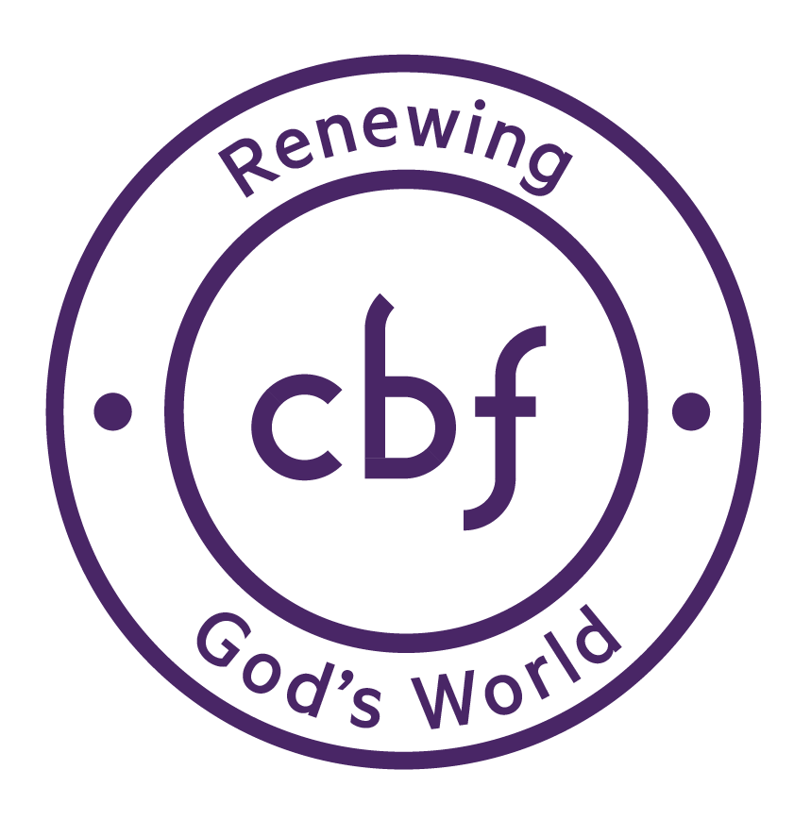

KUTANA KENYA

An Initiative for Environmental Advocacy and Creation Stewardship

When: July 15 – 29

Where: Kenya – 5 distinct eco-systems including:
- Brackenhurst (montane highlands),
- Mara/Serengeti ecosystem (savannah/acacia woodland),
- Kakamega (remnant tropical rainforest),
- Ol Kokwe Island, Lake Baringo (Rift Valley lakes),
- Nairobi (urban jungle!)

What: “Kutana” is a Swahili word signifying ‘mutual encounter’ – in this case, a two-week (plus pre/post trip preparation and study) mission immersion encounter in a cross-cultural setting in one of the most ecologically diverse environments on earth. Participants will encounter and engage ecosystems, people, places, and CBF Global Mission initiatives in the context of a developing nation grappling with multiple environmental challenges.

Who: Students - college aged and above, clergy, young professionals, drawn from a cross-section of CBF life including the Young Baptist Ecosystem Network (Partner schools and seminaries, Student.go, Passport, etc.) and Advocacy partners. Facilitators comprised of CBF staff led by Sam Harrell, Associate Coordinator of Global Missions, previously long-time field personnel in Kenya and director of Africa Exchange.

Why: To forge a conservation ethic centered around ‘Seeking Transformational Development’ and ‘Cultivating Beloved Community,’ drawing connections between God, creation and humanity. Exposure and interaction in this context is designed to educate and inspire participants to become agents of transformation in Renewing God’s World in their home context and circles of influence. There is no substitute for actual exposure to what is real!

With Whom? Local partners in Kenya include: *Africa Exchange *The Maa Trust *World Renew *Stand Up Shout Out

How Much? Cost is $3000 per person including airfare, local travel, lodging and meals (personal incidentals not included). A $500 scholarship from Africa Exchange is available for students upon application.

Contact: sharrell@cbf.net for more information regarding registration and itinerary.

